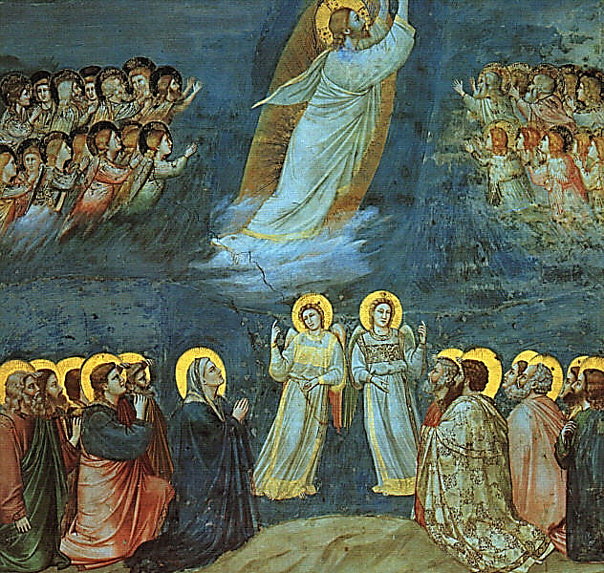
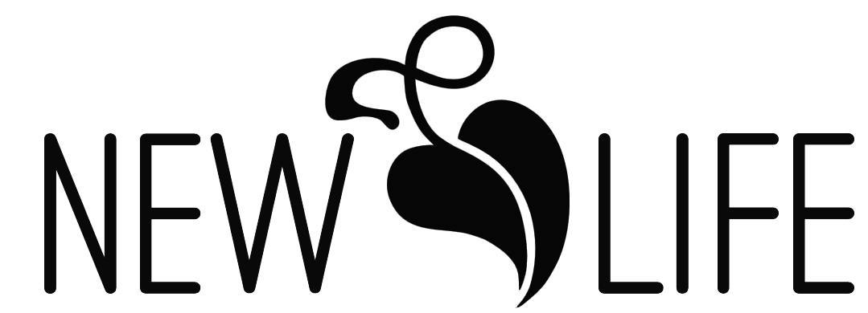
The Seventh Sunday of Easter
The Ascension of our Lord
June 1, 2025
Welcome to Worship
Thank you for joining us for worship today. We welcome you into our fellowship as together we gather in the presence of God – Father, Son, and Holy Spirit.
If you are a visitor, please take a moment to scan the QR code below and fill out the form. We want to acknowledge your presence today with a note of thanks. Please let us know if there is a way we may be of help or encouragement to you today.
If you have any prayer requests or concerns, questions about your faith or the Christian life, if you have updates to your contact information, or if there is anything you need to communicate, please note those remarks on the form.



On the front:
The Ascension, Giotto di Bondone, 1303

Worship Meditations

But to go to Him and withdraw from us was this: to change and make immortal the mortal that he took from us and to lift into heaven that by which he was on earth for our sake. Who would not rejoice at this?
-St. Augustine, 5th c.

That is why
The days of this life are prolonged for us
As a reprieve to reform our evil ways.
-St. Benedict of Nursia, 6th c.

“The Ascension means that heaven is not merely a hope, but a present possession for the Church in [Jesus Christ].”
-John Calvin, 16th c.

“There is not a square inch in the whole domain of our human existence over which Christ, who is Sovereign over all, does not cry: ‘Mine!”
-Abraham Kuyper, 19th c.

Advent + Christmas + Epiphany + Lent + Easter + Pentecost + Trinity
Trinity
Easter is the greatest festival season of the Christian year. It begins with the feast of the Resurrection of Our Lord (Easter Sunday) and lasts for 50 days. After the long preparation of Lent, and the cold dreary winter months that accompany it, and the somber preparation of Maundy Thursday and Good Friday, Easter Sunday erupts into our hearts and souls as a joyous celebration filled with expectation of Christ’s work among us. For 50 days we feast and celebrate Our Lord and his great victory. Easter themes are new life, joy, exuberance, resurrection, hope and love. The liturgical colors for Easter are white and gold.

The Worship of Almighty God
Greeting
The Lord be with you.
And also with you.
Christ is risen!
The Lord is risen indeed!
Alleluia! Christ our Passover is sacrificed for us;
therefore, let us keep the feast. Alleluia! Alleluia!

Let us pray.

Collect
Almighty God, whose blessed Son our Savior Jesus Christ ascended far above all heavens that he might fill all things: Mercifully give us faith to perceive that, according to his promise, he abides with his Church on earth, even to the end of the ages; through Jesus Christ our Lord, who lives and reigns with you and the Holy Spirit, one God, in glory everlasting. Amen.

Call to Congregational Worship
God has gone up with a shout,
the LORD with the sound of a trumpet.
The LORD says to my Lord: "Sit at my right hand,
until I make your enemies your footstool."
The LORD has sworn and will not change his mind,
"You are a priest forever after the order of Melchizedek."
The Lord is at your right hand;
he will shatter kings on the day of his wrath.
God has gone up with a shout,
the LORD with the sound of a trumpet. - Psalm 47:5; 110:1, 4-5

Hail the Day That Sees him Rise
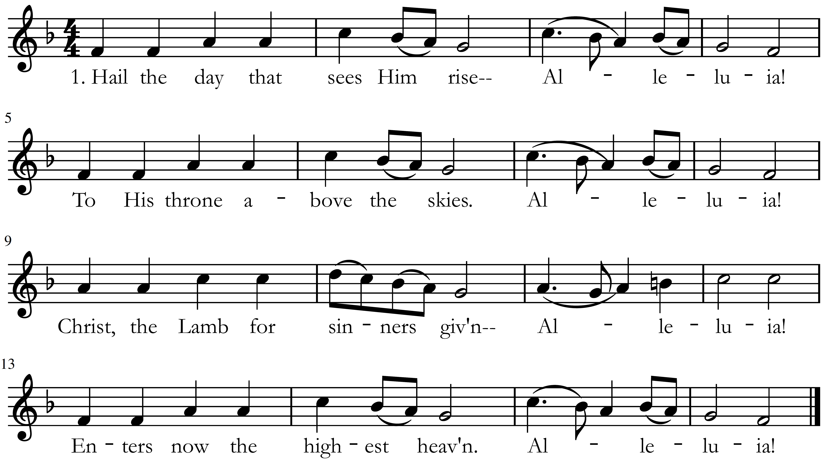

2. There for him high triumph waits; Alleluia!
lift your heads, eternal gates, Alleluia!
he has conquered death and sin, Alleluia!
take the King of glory in! Alleluia!

3. See, he lifts his hands above! Alleluia!
See, he shows the prints of love! Alleluia!
Hark! his gracious lips bestow Alleluia!
blessings on his church below. Alleluia!

4. Lord, beyond our mortal sight, Alleluia!
raise our hearts to reach thy height; Alleluia!
there thy face unclouded see, Alleluia!
find our heav'n of heav'ns in thee! Alleluia!

Antiphon
God has gone up with a shout,
the LORD with the sound of a trumpet.
The LORD says to my Lord: "Sit at my right hand,
until I make your enemies your footstool."
Words: Charles Wesley, 1739
Music: Robert Williams, 1817

A Hymn of Glory Let us Sing
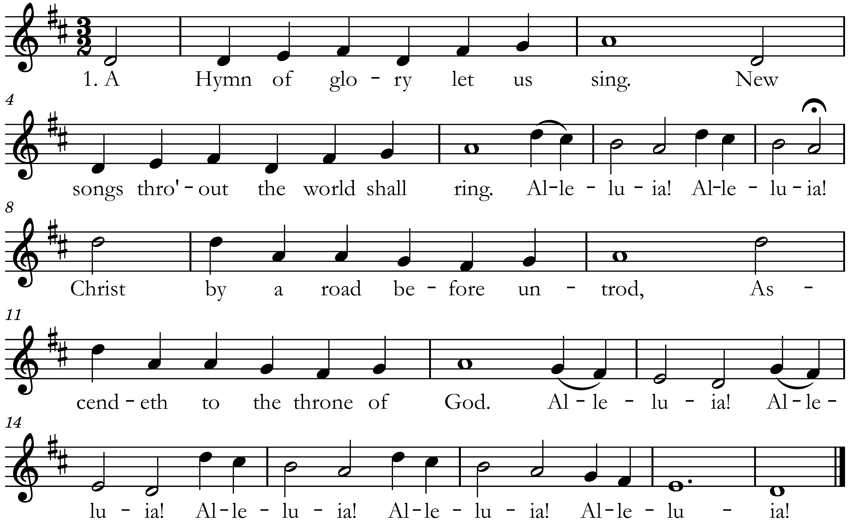

2. The holy apostolic band
Upon the Mount of Olives stand;
Alleluia! Alleluia!
and with his followers they see
Jesus' resplendent majesty.
Alleluia! Alleluia! Alleluia! Alleluia! Alleluia!

3. To whom the angels, drawing nigh,
"Why stand and gaze upon the sky?
Alleluia! Alleluia!
This is the Savior," thus they say,
"this is his noble triumph day."
Alleluia! Alleluia! Alleluia! Alleluia! Alleluia!
Words: The Venerable Bede, 7th c.
Translated by: Benjamin Webb, 1854
Music: Geistlich Kirchengesäng, Cologne, 1623

4. "Again shall ye behold him so
as ye today have seen him go,
Alleluia! Alleluia!
in glorious pomp ascending high,
up to the portals of the sky."
Alleluia! Alleluia! Alleluia! Alleluia! Alleluia!

Confessing Our Sins
Alleluia! Christ our passover has been sacrificed for us,
Therefore let us keep the feast,
not with the old leaven, the leaven of malice and evil,
but with the unleavened bread of sincerity and truth. Alleluia!
-1 Corinthians 5:7-8

Almighty God, in lifting up your Son Jesus Christ into the heavens and seating him at your right hand you have inaugurated his Kingship over all things and made heaven not only a future hope, but also a present possession for us, Your people. We confess to you that we have not made Christ also the Lord of our lives. We have ignored and lessened his kingship over our vocations, our pastimes, and our possessions. We also confess to you that we have not always lived in that future hope and our present possession of heaven. We have given ourselves over to doubt and to fear, to shame and to guilt instead of always living in light of the truth that we are seated with Christ by you in the heavenly places. Forgive us, God of mercy. Help us to trust your power to change our lives and make us new, that we may know the joy of life abundant given in Jesus Christ, the risen Lord.
Lord, have mercy.
Christ, have mercy.
Lord, have mercy.

Continue your confession of sins in silent prayer

Receiving Assurance of Pardon
And said to them, "Thus it is written, that the Christ should suffer and on the third day rise from the dead, ⁴⁷ and that repentance for the forgiveness of sins should be proclaimed in his name to all nations, beginning from Jerusalem. - Luke 24:46-47

Glory to God in the highest!
And peace to his people on earth!

See, the Conqueror Mounts in Triumph

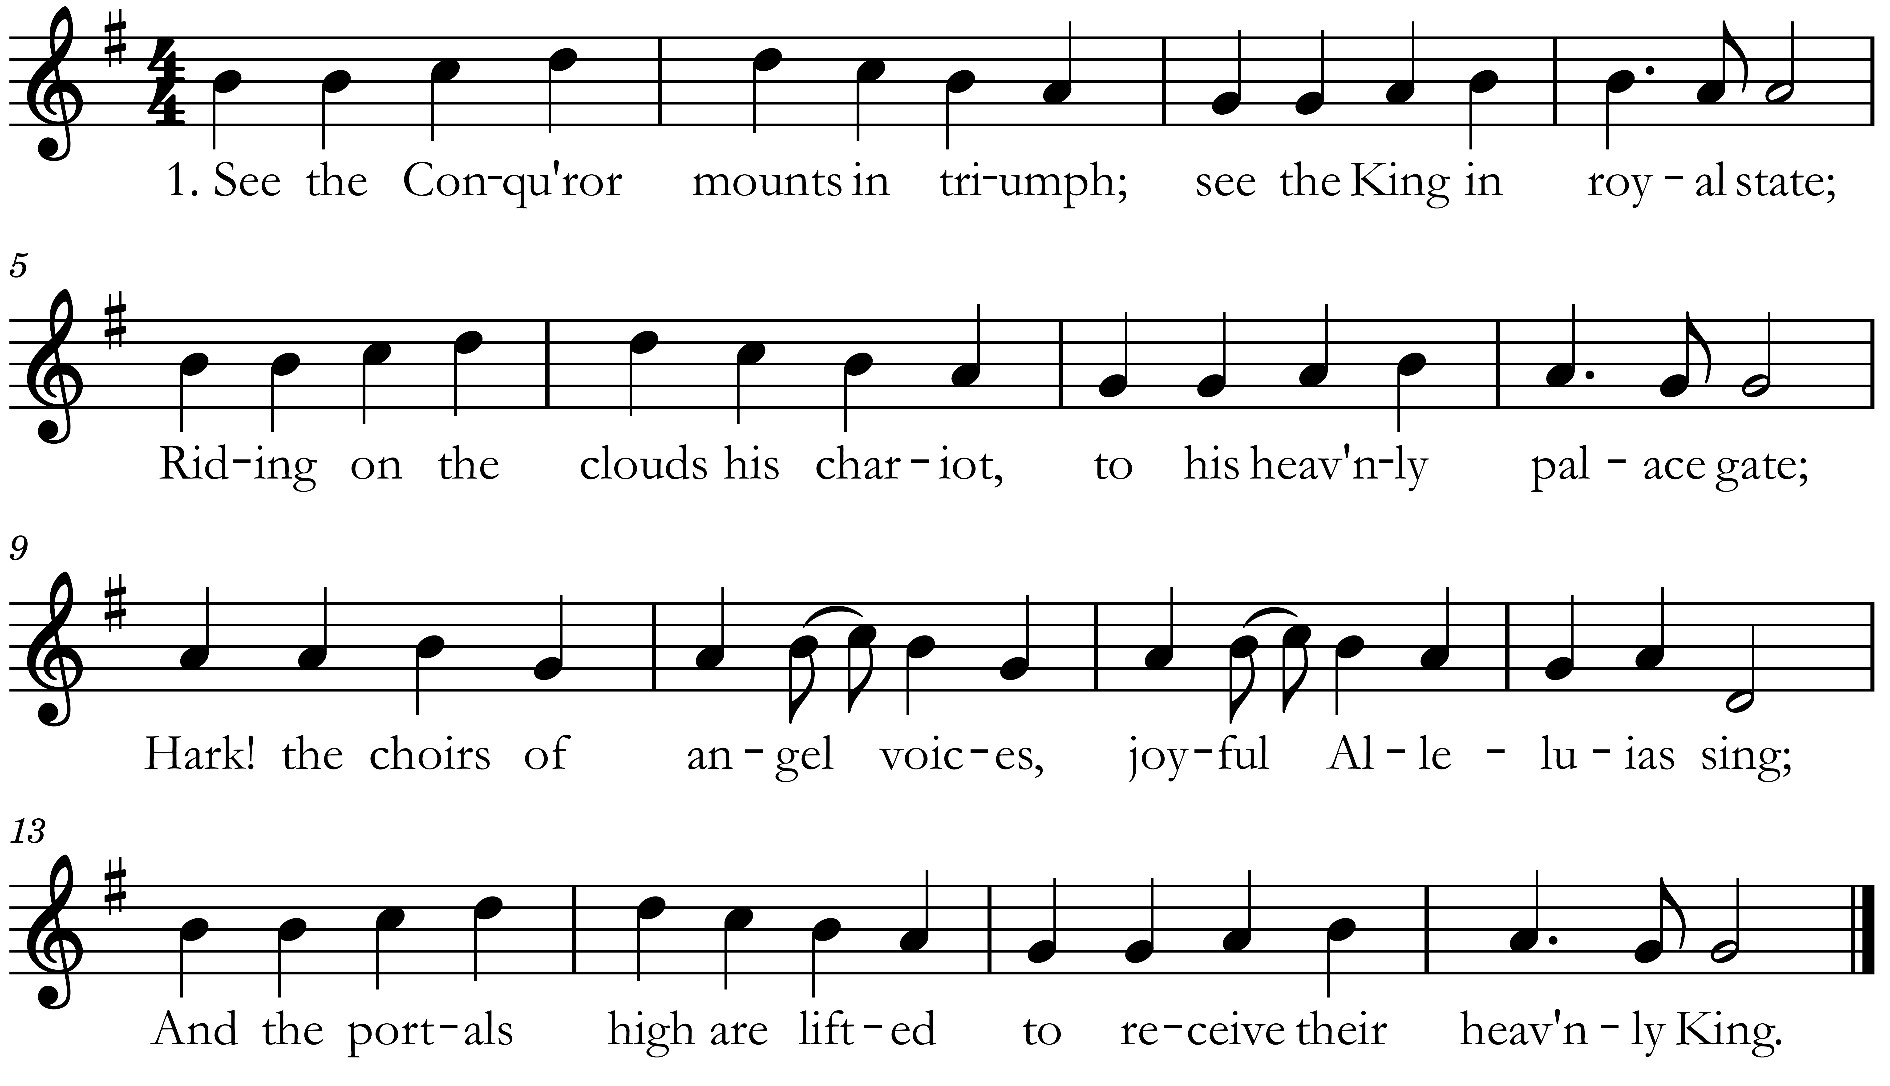

2. Who is this that comes in glory,
with the trump of jubilee?
Lord of battles, God of armies,
he has gained the victory;
he who on the cross did suffer,
he who from the grave arose,
he has vanquished sin and Satan,
he by death has spoiled his foes.

3. You have raised our human nature
in the clouds to God's right hand;
there we sit in heav'nly places,
there with you in glory stand:
Jesus reigns, adored by angels,
man with God is on the throne;
mighty Lord, in your ascension
we by faith behold our own.

Words: Christopher Wordsworth, 1862
Music: L. V. Beethoven, 1824

Prayer of Adoration
Dear Jesus, you ascended into heaven where you sit as King over all things. Help us always to trust that you are in charge and to obey your rules and laws. You rule! We love you! Amen.

Praises and Petitions
Please see page 22 for additional prayers this week.

Children’s Moment
All children may come forward for a brief lesson and prayer by Pastor Tim.

Passing of the Peace
While the children are being dismissed, we will have a brief time of welcome and greeting. You are welcome to “pass the peace of Christ” to one another.

Greeting and Announcements
If you are visiting, or have a contact update, please scan the QR code below and fill out the form.
Please see announcements on page 23.

The Lord Speaks Through His Word

New testament reading: Ephesians 4:1-13

I therefore, a prisoner for the Lord, urge you to walk in a manner worthy of the calling to which you have been called, 2 with all humility and gentleness, with patience, bearing with one another in love, 3 eager to maintain the unity of the Spirit in the bond of peace. 4 There is one body and one Spirit—just as you were called to the one hope that belongs to your call— 5 one Lord, one faith, one baptism, 6 one God and Father of all, who is over all and through all and in all. 7 But grace was given to each one of us according to the measure of Christ's gift. 8 Therefore it says,

“When he ascended on high he led a host of captives,
and he gave gifts to men.”

9 (In saying, “He ascended,” what does it mean but that he had also descended into the lower regions, the earth? 10 He who descended is the one who also ascended far above all the heavens, that he might fill all things.) 11 And he gave the apostles, the prophets, the evangelists, the shepherds and teachers, 12 to equip the saints for the work of ministry, for building up the body of Christ, 13 until we all attain to the unity of the faith and of the knowledge of the Son of God, to mature manhood, to the measure of the stature of the fullness of Christ.

Reader: This is the Word of the Lord
People: Thanks be to God!

The Psalm
Psalm 47, Antiphon V. 5

God has gone up with a shout,
the Lord with the sound of a trumpet.

¹ Clap your hands, all peoples!
Shout to God with loud songs of joy!
² For the Lord, the Most High, is to be feared,
a great king over all the earth.
³ He subdued peoples under us,
and nations under our feet.
⁴ He chose our heritage for us,
the pride of Jacob whom he loves.

⁵ God has gone up with a shout,
the Lord with the sound of a trumpet.
⁶ Sing praises to God, sing praises!
Sing praises to our King, sing praises!
⁷ For God is the King of all the earth;
sing praises with a psalm!

God has gone up with a shout,
the Lord with the sound of a trumpet.

⁸ God reigns over the nations;
God sits on his holy throne.
⁹ The princes of the peoples gather
as the people of the God of Abraham.
For the shields of the earth belong to God;
he is highly exalted!

Glory be to the Father and to the Son and to the Holy Spirit
As it was in the beginning is now and ever shall be world without end. Amen.

God has gone up with a shout,
the Lord with the sound of a trumpet.

The Gospel: luke 24:44-53

Then he said to them, “These are my words that I spoke to you while I was still with you, that everything written about me in the Law of Moses and the Prophets and the Psalms must be fulfilled.” ⁴⁵ Then he opened their minds to understand the Scriptures, ⁴⁶ and said to them, “Thus it is written, that the Christ should suffer and on the third day rise from the dead, ⁴⁷ and that repentance for the forgiveness of sins should be proclaimed in his name to all nations, beginning from Jerusalem. ⁴⁸ You are witnesses of these things. ⁴⁹ And behold, I am sending the promise of my Father upon you. But stay in the city until you are clothed with power from on high.”

⁵⁰ And he led them out as far as Bethany, and lifting up his hands he blessed them. ⁵¹ While he blessed them, he parted from them and was carried up into heaven.* ⁵² And they worshiped him and returned to Jerusalem with great joy, ⁵³ and were continually in the temple blessing God.

Reader: The Gospel of the Lord
People: Glory to you, O Lord!

*At the moment that the ascension of Jesus is read in the Gospel, the Paschal Candle is extinguished, and the Easter Season is officially over. The time between the Ascension and Pentecost is known as the Novena, for the nine-day period spent in prayer for the outpouring of the Holy Spirit. This period marks the same period between Ascension and Pentecost when Jesus told the disciples to stay in the Upper Room and pray for the Spirit to come (Luke 24:49; Acts 1:4, 14)
Hearing the Word Preached

Sermon Title: Ad Astra
Sermon Text: Luke 24:36-53
Preacher: Rev. Dr. Timothy R. LeCroy

Affirmation of Faith
The Nicene Creed

I believe in one God, the Father Almighty, maker of heaven and earth, and of all things visible and invisible.
And in one Lord Jesus Christ, the only-begotten Son of God, begotten of His father before all worlds, God of God, Light of Light, true God of true God, begotten, not made, being of one substance with the Father, by whom all things were made; who, for us men and for our salvation, came down from heaven and was incarnate by the Holy Spirit and the virgin Mary, and was made man; and was crucified also for us under Pontius Pilate. He suffered and was buried. And the third day He rose again according to the scriptures, and ascended into heaven, and sits at the right hand of the Father. And He shall come again with glory to judge both the living and the dead, whose kingdom shall have no end.
And I believe in the Holy Spirit, the Lord and giver of life, who proceeds from the Father and the Son, who with the Father and the Son together is worshiped and glorified, who spoke through the prophets.
And I believe in one holy catholic and apostolic church. I acknowledge one baptism for the forgiveness of sins. And I look for the resurrection of the dead and the life of the world to come. Amen.

The Offering
New Life is supported by the generous gifts of our church members and friends. If you are visiting, you are not expected to give, but if the Lord has blessed you today and you would like to support our ministry, it would be most appreciated.
If you don’t have cash or check, you can also give on-line at www.newlifeithaca.org/giving/

Whoever sows sparingly will also reap sparingly, and whoever sows bountifully will also reap bountifully. Each one must give as he has decided in his heart, not reluctantly or under compulsion, for God loves a cheerful giver.
-2 Cor. 9:6-7

The Presentation of the Gifts

Eucharist
THE GREAT THANKSGIVING
The Lord be with you.
And also with you.
Lift up your hearts!
We lift them up to the Lord!
Let us give thanks to the Lord, our God.
It is proper and right to do so.

Truly it is proper, right, and salutary that we should at all times and in all places give thanks unto You, O Lord, holy Father, almighty and everlasting God, through Jesus Christ our Lord. Who after His resurrection appeared openly to all His disciples and in their sight was taken up into heaven that He might make us partakers of His divine nature. Therefore, with angels and archangels and all the company of heaven, and with the Church on earth, we praise and magnify Your glorious name, evermore praising You and singing:

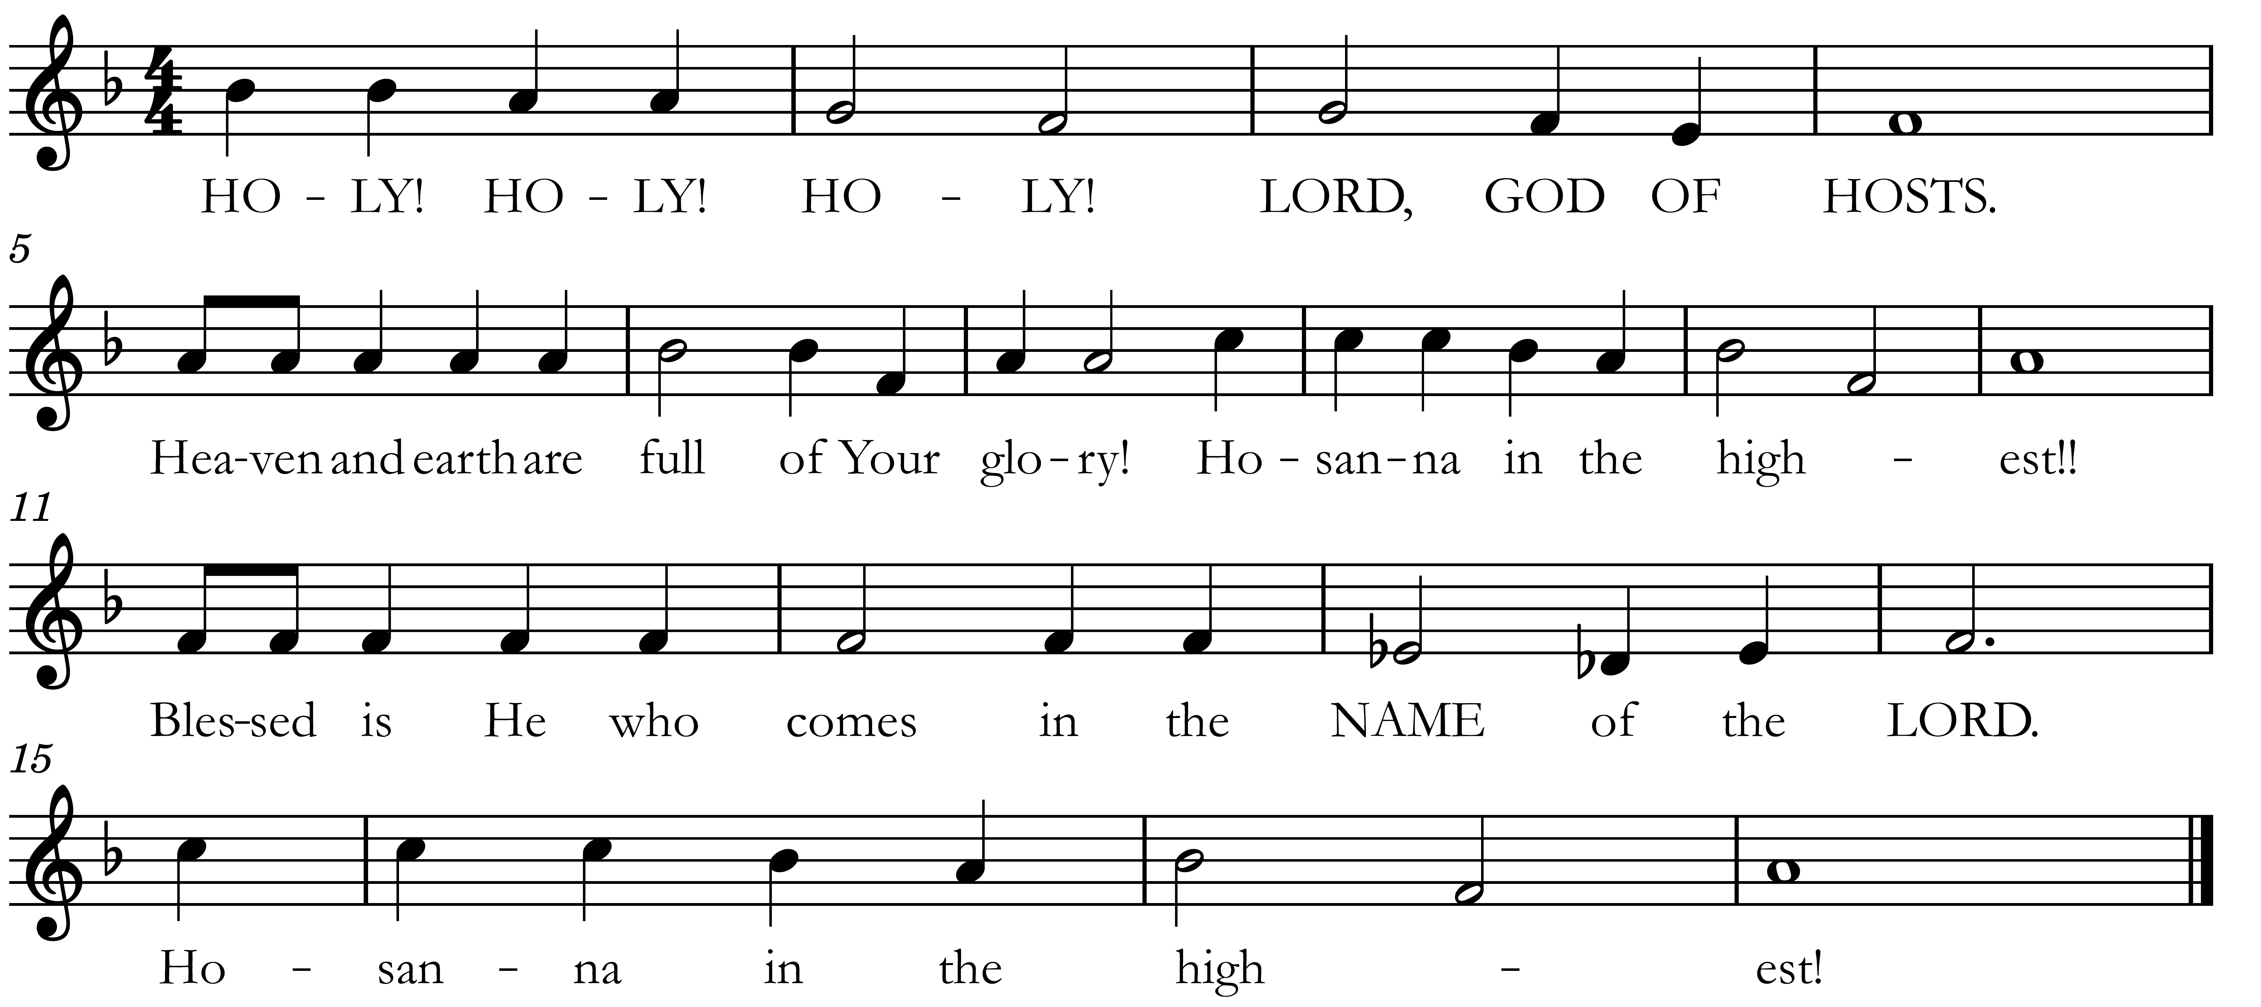

WORDS OF INSTITUTION AND PRAYER

The Acclamation
For as often as we eat this bread and drink this cup we proclaim the Lord’s death until He comes.
Amen. Come, Lord Jesus.
Therefore, we proclaim the mystery of Faith:
Christ has died; Christ is risen; Christ will come again.

The pastor prays a further prayer for the Holy Spirit to bless our communion meal.

THE LORD’S PRAYER
Our Father, who art in heaven:
Hallowed be Thy Name,
Thy kingdom come.
Thy will be done,
On earth as it is in heaven.
Give us this day our daily bread.
And forgive us our debts,
As we forgive our debtors.
And lead us not into temptation,
But deliver us from evil.
For Thine is the kingdom,
and the power,
and the glory,
For ever and ever.
Amen.

The Invitation
New Life Presbyterian Church welcomes all baptized Christians who trust in Jesus Christ to receive Holy Communion with us.
-If this does not describe you, you are invited to come forward, crossing your arms in front of your chest when you reach the front, to receive a blessing from the pastor.

DISTRIBUTION
The congregation will come forward row-by-row, forming two lines in the center aisle. Cup your hands together to receive the bread, then proceed outwardly to the wine tray. There is juice in the very center and wine on the outside. Then use the outside aisle to return to your seat and wait until we eat and drink together.

Let All Mortal Flesh Keep Silence

2. King of kings, yet born of Mary,
as of old on earth he stood;
Lord of lords, in human vesture,
in the body and the blood,
he will give to all the faithful
his own self for heav'nly food.

3. Rank on rank the host of heaven
spreads its vanguard on the way,
as the Light of light descendeth
from the realms of endless day,
that the pow'rs of hell may vanish
as the darkness clears away.

4. At his feet the six-winged seraph;
cherubim, with sleepless eye,
veil their faces to the presence,
as with ceaseless voice they cry,
"Alleluia, alleluia,
alleluia, Lord Most High!"

Words: The Liturgy of St. James, 4th c.
Paraphraser: Gerard Moultrie, 1864
Music: 17th c. French Carol
Arranger: Ralph Vaughan Williams, 1906
Prayers for Those Not Communing
New Life Presbyterian Church welcomes all baptized Christians who trust in Jesus to receive Holy Communion with us. If you are not able to receive Communion, please use the time to mediate on one of the following prayers:

Prayer for Those Searching for Truth
Lord Jesus, you claim to be the way, the truth, and the life. Grant that I might be undaunted by the cost of following you as I consider the reasons for doing so. If what you claim is true, please guide me, teach me, and open me to the reality of who you are. Give me an understanding of you that is coherent, convincing, and that leads to the life you promise. Amen.

Prayer of Belief
Lord Jesus Christ, I recognize that I am weaker and more sinful than I ever dared admit, but through you I am more loved and accepted than I ever dared hope. I thank you for paying my debt on the cross, taking what I deserved in order to offer me complete forgiveness. Knowing that you have been raised from the dead, I turn from my sins and receive you as my Savior and Lord. Amen.

For Those Struggling with Sin
If you are a baptized believer in Christ who is struggling with sin, you should still come forward for communion. As it says in our Larger Catechism 172:

One who doubteth of his being in Christ, or of his due preparation to the sacrament of the Lord's supper, may have true interest in Christ, though he be not yet assured thereof; and in God's account hath it, if he be duly affected with the apprehension of the want of it, and unfeignedly desires to be found in Christ, and to depart from iniquity: in which case (because promises are made, and this sacrament is appointed, for the relief even of weak and doubting Christians) he is to bewail his unbelief, and labour to have his doubts resolved; and, so doing, he may and ought to come to the Lord's supper, that he may be further strengthened.

The Holy Communion
We partake together of the most holy body and blood of our Lord and Savior Jesus Christ.
After the communion the pastor prays a prayer of blessing.

Benediction
The Pastor pronounces a blessing upon the congregation from Scripture.

Doxology
Praise God, from whom all blessings flow
Praise Him all creatures here below
O praise him, alleluia!
Praise, praise the Father, praise the Son,
and praise the Spirit, three in one.
O praise him, O praise him,
alleluia, alleluia, alleluia!
Words: Thomas Ken
Music: Geistliche Kirchengesang Cologne, 1623

Declaration of Peace
May the Peace of Christ be with you.
And also with you.
Go in peace.
All music reprinted under CCLI SongSelect terms of use.
All rights reserved. www.ccli.com
CCLI License #153561
CCLI Streaming License #21567482
All biblical text reprinted by permission from
The English Standard Version
The Prayers of the People
PCA CHURCHES AND PASTORS IN THE NEW YORK STATE PRESBYTERY
- New Hope Presbyterian Church, Vestal; Alex Howarth, pastor

SISTER CHURCHES IN ITHACA
- Tabernacle Baptist Church; Elijah Beltz, pastor

NEW LIFE ALUMS IN VOCATIONAL MINISTRY
- Bob and Jenny Dalberth (counseling support for New York City area churches)

GOVERNMENT AND POLITICAL LEADERSHIP
- Ithaca Mayor Robert Cantelmo; the Common Council and the Administration Committee; City Manager Deb Mohlenhoff; and local governments in Tompkins County and surrounding villages and townships; that they may govern with wisdom according to your word that we may all live quiet and peaceable lives.

NEW LIFE CHURCH
- Lucy LeCroy: Pray for her pregnant therapist Sophie, who has had to begin her maternity leave earlier than expected.
- Hannah Eagelson: Praise that her husband Nathan completed and submitted his tenure package.
- Katie Ribbens & Jake Battaglia: Praise that they were married; pray for their marriage and for their summer internship in Idaho
- Steve & Sheryl Froehlich: Pray for Sheryl’s mom as her health continues to decline due to age. Pray for Sheryl and Steve as they make decisions regarding her care, and as they travel to and from Ohio to see her.
- Anne Williamson: Pray for Abigail as she participates in her recital today.
- Pray for all New Life alums working for the federal government, that they would retain their jobs and funding during this time. Pray also for those working at Cornell who may be affected by the related hiring freezes and budget cuts.
- Thanks be to God a good financial report for April!
If you do not wish to have praises and requests shared during the worship service printed in the bulletin for the next three weeks, please inform Angela Brodie in an email (angelabrodie@gmail.com).

life @ new life

Pentecost Pulled Pork Potluck – June 8th
We will celebrate the feast of Pentecost with some of Pastor Tim’s pulled pork. Look for a sign up sheet for appetizers, sides, and desserts.

Morning Prayer & Pastor Tim’s “Office Hours” – Tuesdays
Join us on Tuesdays at 7:45AM for a short time of prayer. We will be using the traditional form for the Daily Office, which has confession of sin, psalms, scripture readings, and intercessory prayer; and our time together should last about 20 minutes. Immediately following Morning Prayer on Tuesdays, Pastor Tim will be available at the church for consultation or conversation. Please feel free to stop by.

contact us
Senior Pastor:
The Reverend Dr. Timothy R. LeCroy
tim@newlifeithaca.org

Elder:
David Williamson – david@newlifeithaca.org

Church Contact:
950 Danby Road
Suite 195
Ithaca, New York 14850

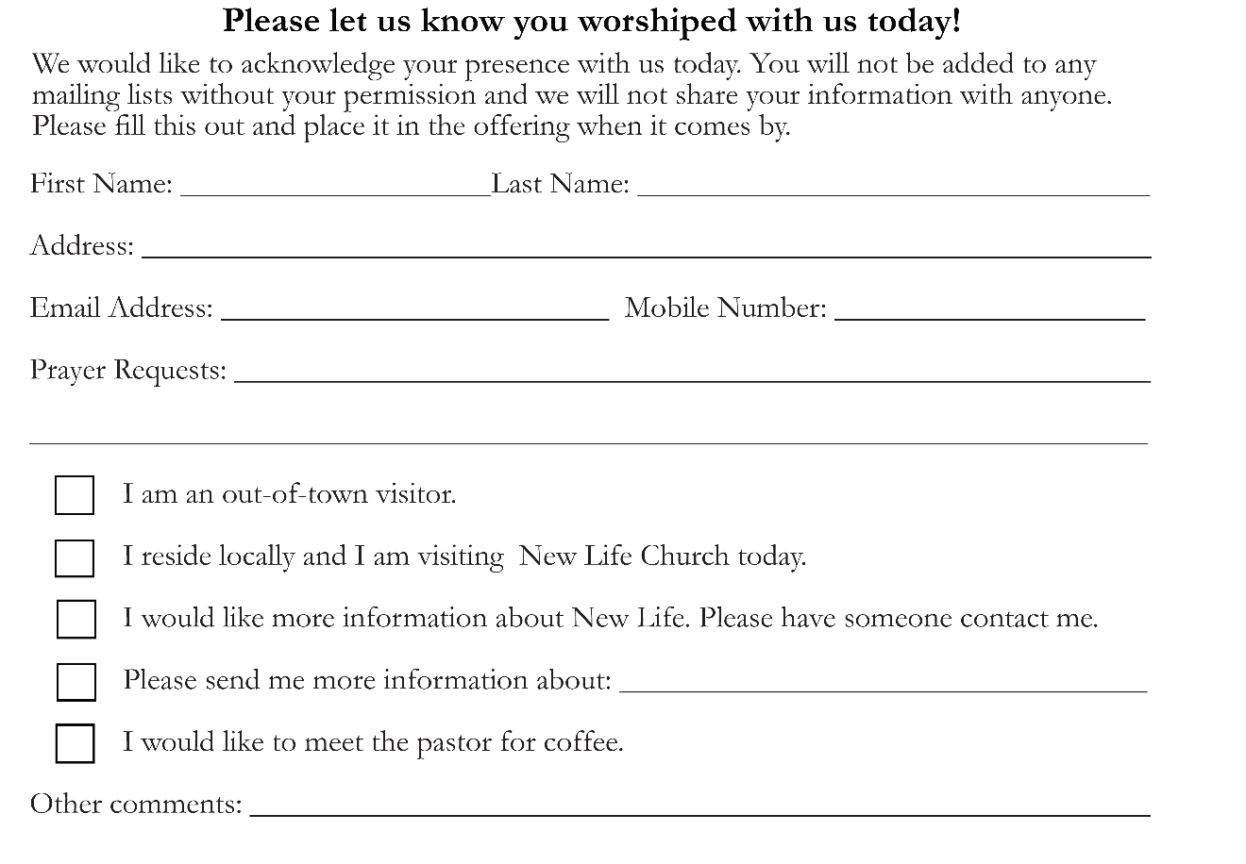
607.277.8398 www.newlifeithaca.org
New Life Presbyterian is a congregation of the Presbyterian Church in America

